Video and Screen Capture in Pega

To achieve this in community we have the Component called as Media Capture for Pega

So first we need to download the JAR from the marketplace

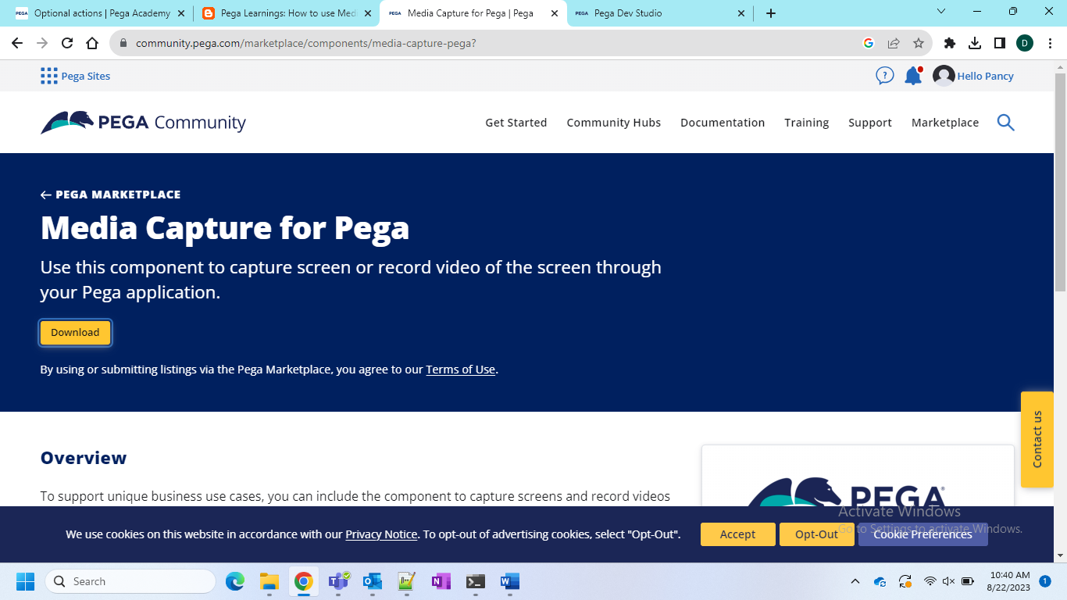

Now download and extract the JAR file.

Now go to the application definition and then go to the components and click on Install New

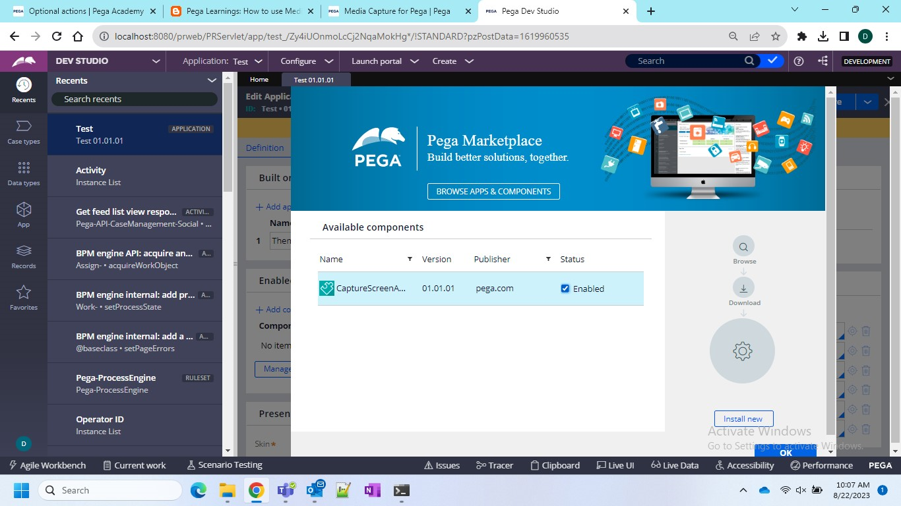

If this is not working then you can go by traditional mmethod of import from application > distribution > import

After import we will have the component and the ruleset version 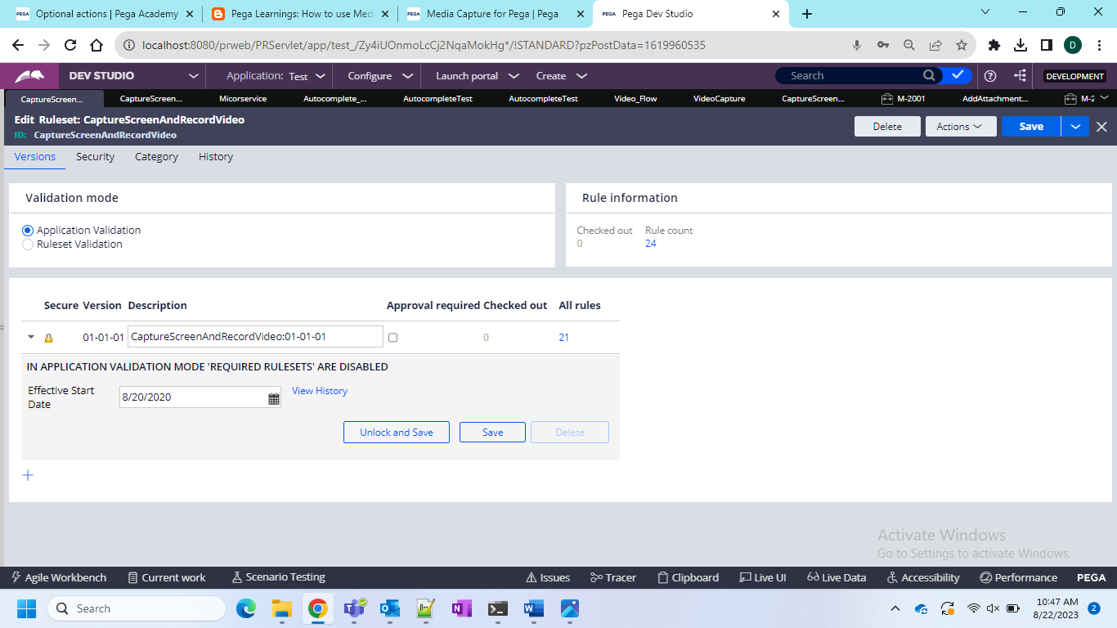

And in these there are couple of pre defined rules by pega

Now create one case type and a flow action and a section…

And as for the section is concerned OOTB section is given with the component in baseclass section

Refer that section here ..

Section- **CaptureScreenAndRecordVideoExample**

And now we need to run the case and click on capture screen and record video

After that we can see that in the files and attachments

And once we open that video capture then we can see what all is recorded…

